Was Norway’s HAARP Facility EISCAT Responsible for the Norway Spiral?

2010/01/21

By Henrik Palmgren | [redicecreations.com](http://www.redicecreations.com/%20http:/www.redicecreations.com)

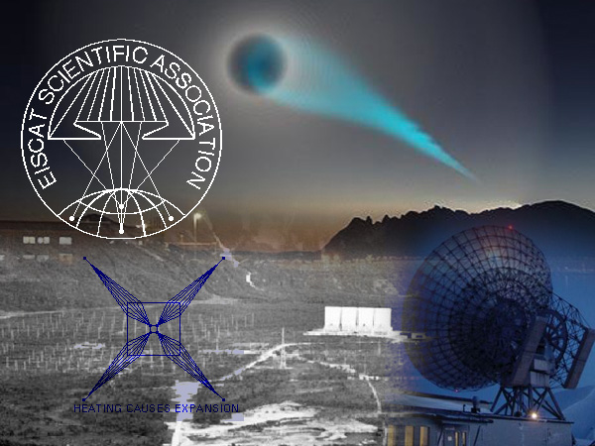

**Have you ever heard of EISCAT (European Incoherent Scatter facility)?**  
  
EISCAT, short for the European Incoherent Scatter facility, is located at Ramfjord, about 20 Kilometers South of Tromsø in Norway where the "[Norway Spiral](http://www.redicecreations.com/article.php?id=9035)" or the Blue Spiral was seen back in December 2009. It's been said that the "spiral test" or "experiment" caused all kinds of [side effects](http://www.redicecreations.com/article.php?id=9471).

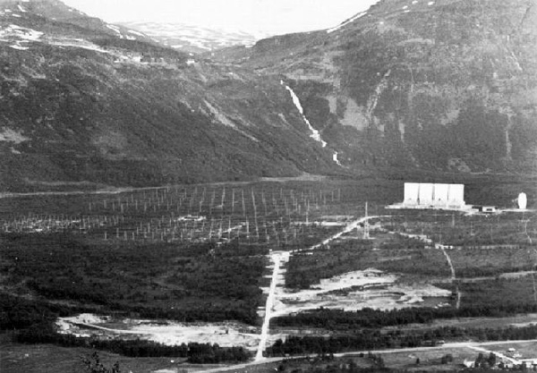

At the EISCAT in Tromsø they also have an Ionospheric Heater facility with a Frequency Coverage of 4 to 8 MHz. In contrast, HAARP in Gakona, Alaska has a Frequency Coverage of 2.8 - 10 MHz. You could say that EISCAT is the HAARP of Scandinavia.

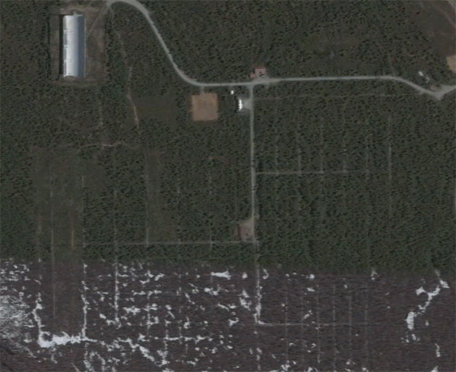

Image from above in [Google Maps](http://maps.google.com/maps?ll=69.583662,19.214116&z=16&t=h&hl=sv)

The following is from the [EISCAT website](http://www.eiscat.se:8080/heating/):

The Heater is used for ionospheric modification experiments applying high-power transmissions of high-frequency electro-magnetic waves to study plasma parameters in the ionosphere. The name Heating stems from the fact that these high power electromagnetic waves, which are transmitted into the ionosphre with high-gain atennas, heat the electrons and thus modify the plasma state. To create plasma turbulence, the transmitted frequencies have to be close to the plasma resonances, which are 4 to 8 MHz.